Stop Motion Help Sheet
Be sure to do the following in this order so that your stop motion will sequence together properly! Be sure that you take your pictures and leave the names unchanged so that they are a sequence of images.
TIPS
- Take all pics at one setting. If you are using something important that needs to stay put, tape it down.
- Use a tripod!!! SERIOUSLY!!!
- Light the area or be sure your flash fires every time.
- Check after each picture; if it’s not good or blurry, delete in camera to maintain the number sequence.
- Copy your pics to the computer and check to be sure they are all there before you delete them from the card.
- 75 pictures is about 17 seconds run time. Do the math.
- It really helps to shoot with a partner. A buddy can move the items for you while you direct and capture the images.
Set Still Images Default
By default, still images come in lasting 5 seconds (150 frames at 30fps). For stop motion, you don’t want frames to last nearly that long. My suggestion is to set this to 10 frames. You can experiment with others, but just remember that this must be set BEFORE you import the still photos into the project.
Edit> Preferences> Still Images
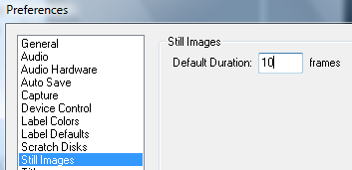
Change Project Settings to Scale Photos
This is uber important! If you do not do this step, your digital camera images will be huge, hang off the screen, and require you to manually resize them all, which is very time consuming. Save yourself a headache and set this!
Project> Project Settings> General
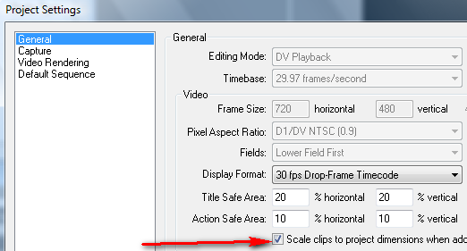

Import all Your Clips
File> Import
Set it so Premiere will Put Them in Order
You don’t really want to drag 300 pictures to the timeline, do you? Well, do you!? Okay, so select all your files in the Project window (click the top one, hold SHIFT, and click the last one or if you never clicked off of them, they probably are still highlighted). Then, click Project> Automate to Sequence
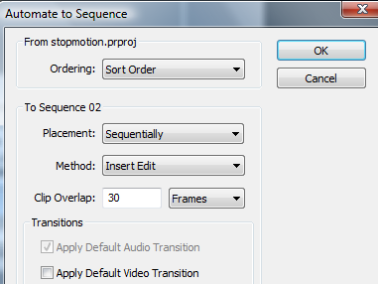
Be sure to UNCHECK apply default transition!! You do not want a transition!!!
Scoot them Down!
If you didn’t already start at the 5 second point or however long you want your intro to be (you can make it before doing all the still image stuff above), you will have to select all the images and scoot them down. Simply press the track select button and click on the first clip to select them. Then, switch to the move arrow and scoot them down. Then, you can create your intro on the next video line (above it).
